All frames T4 camera; 30um Ovio slit; 17mm diameter lenses stopped to 13mm.

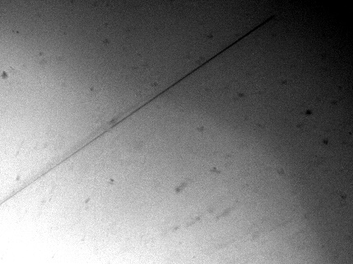 30 mm fl. OK for Lodestar

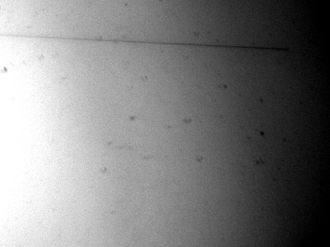 32 mm fl **XXX**

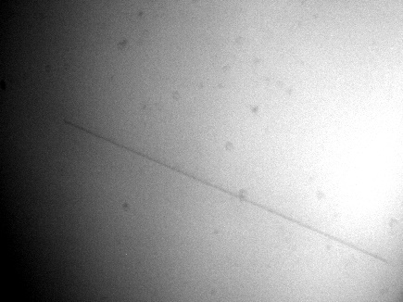 28 mm fl Slightly better, perhaps Lodestar for better field?

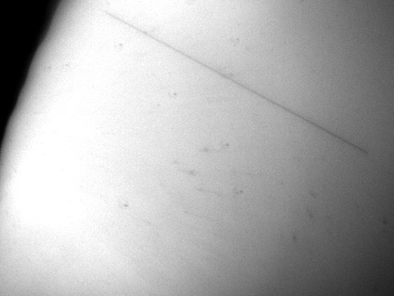 26 mm fl Probably the best compromise for the T7. Good FoV

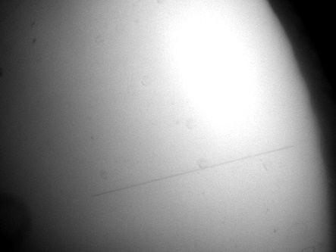 25 mm fl Wortyh trying for the T7.